Development Request
Aria Systems
EDI Automatic PO Depletion
Custom Program#:

Changes on Receiving and Process EDI Orders

Template Header
Product: | Aria27
Module: | EB
Customer name: | GMA
Installed Modules: | All modules
Parameters setting :

.

Add-in Name: Automatic EDI PO Depletion
Add-in Objective:
This modification on C200215 enables automatic PO depletion from multi bulk orders. We need to be able to deplete one style in a PO from many Bulk orders
- Update process:
  - This is the part of the program where an EDI confirmation (release) order is depleted from an existing bulk order for this customer.
  - In case of GMA only, a new browse screen will appear for every PO, style/color being updated. Please make a note that for a multi-store order, we will only display one line for that PO, style/color. This browse will show the following fields: Aria Order #, Customer code, Customer PO#, start date, completion date, pack ID, pack Color, pack Size, Pack version, unit price for each style/color and quantity for each style/color.
  - For those style/colors that were on a range pack, the BULK order # will already be updated as it was supplied to the system on the conflict resolution screen described above. In this case user will not be able to change the Bulk Order # for such range packs.
  - For all other style/colors that were not on an range pack, if the incoming order matches with an existing BULK order then all the matching BULK orders will be displayed in a related grid (See Snapshot below), where the user can select one or many BULK orders and enter the quantity for each. In this scenario, the relationship between PO line and BULK orders is one to many. For each BULK order selected we will create a PO line; i.e. If the user selects to deplete style A from BULK orders B1, B2 then we will create 2 lines in the PO for B1 and B2.
  - Matching BULK order will be determined by making sure that the following fields match on the incoming order with an existing BULK order in the system: Customer code, Customer PO#, start date, completion date, pack/color/size/version (if the style/color was on a pack), price and quantity.
  - User will have the ability to leave the Bulk order field blank. If it is left blank, then no depletion will occur for that PO/style/color. Please keep in mind if all style/colors on a PO are not to be depleted, then the user will have to make sure that all PO/Style/color lines in this browse have the BULK order # field empty.
  - The Grid showing all possible bulk orders will display the following fields: Order #, Customer code, Customer PO#, start date, completion date, pack/color/size/version (if the style/color was on a pack), price and quantity.
  - Unfortunately, it is not possible to allow the user to select a BULK order and go into the order screen with that Bulk order selected to see the entire order. However, the user can have another session of the Aria running where he can enter the bulk order # and see the entire order.

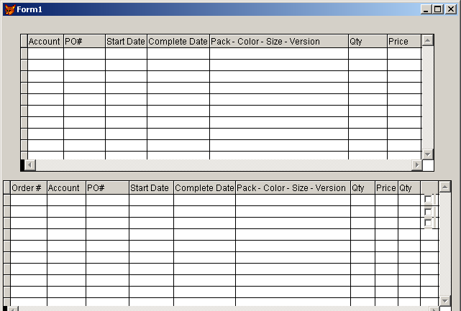

Development Cost | $ .00
Customer signature

Date signed
Payment Terms | 50 % due upon signing.  50% due upon delivery of the project.  (No work on this project will begin until the deposit is received)
Estimated completion time | 6 –8 weeks from the date of signing this document

